2024 10th International Conference on Power Electronics Systems and Applications

5th – 7th June 2024
Organizer: | Technical Sponsor:
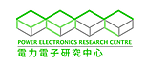 | 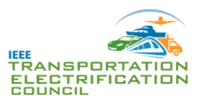

Call for Special Session
Title of the Special Session
Objective of Special Session
(100 words)
Subtopics
(Maximum 5 topics)
Name of the Special Session Chair:
Designations:
Institutions:
Email Id:
Name of the Co-chairs:
Designations:
Institutions:
Email Id:
Short Profile of Special session chair and co-chairs with Photo

